WEEK-7---SNS,SQS& S3-SNS-SQS-LAMBDA SERVICES

1) Simple Notification Sevice (SNS)

A) Create SNS Topic and Send Message to Email
We will:
- Create an SNS Topic
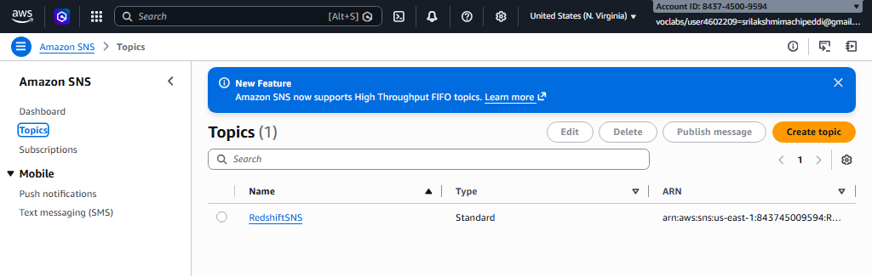
- Create an Email Subscription
- Confirm the subscription
- Publish a test message

Step 1: Create SNS Topic
- Login to AWS Console
- In search bar → Type SNS
- Open Amazon SNS (Simple Notification Service)
- In left panel → Click Topics
- Click Create topic

Configure:
- Type → Select Standard
- Name → MyEmailTopic
- Leave other settings default (unless required)
- Click Create topic
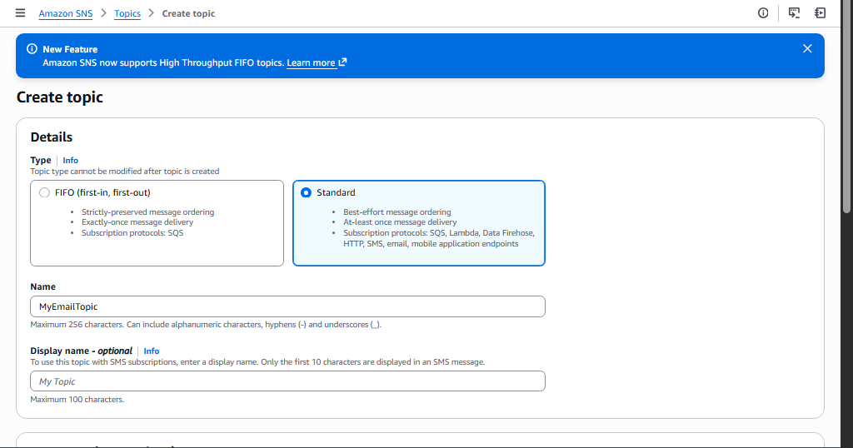

Step 2: Create Email Subscription
- Open your created topic
- Go to Subscriptions tab
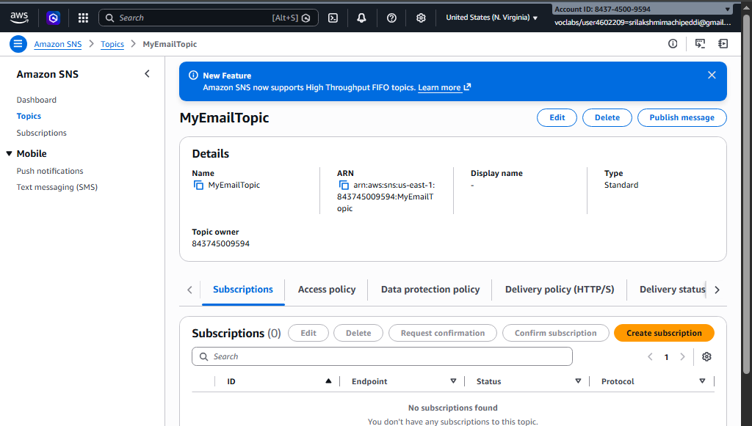
- Click Create subscription

Configure:
- Protocol → Select Email
- Endpoint → Enter your email address
- 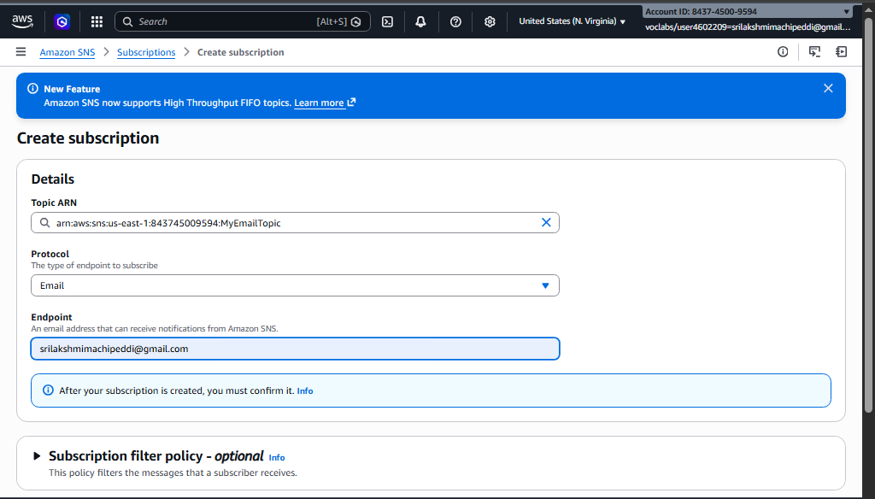
- Click Create subscription

Step 3: Confirm Subscription
- Go to your email inbox
- You will receive a mail from Amazon SNS
- Click Confirm subscription
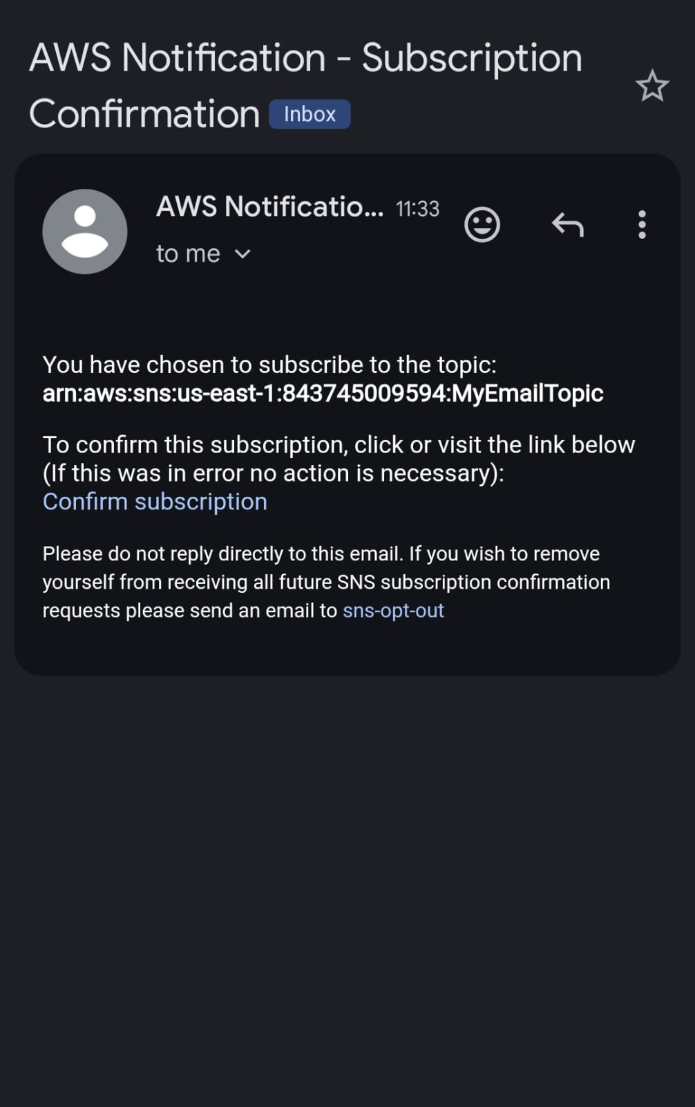
Now your email is successfully subscribed 🎉
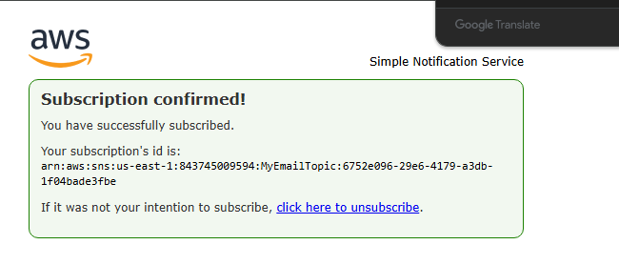

Step 4: Publish Test Message
- Open your SNS topic
- Click Publish message
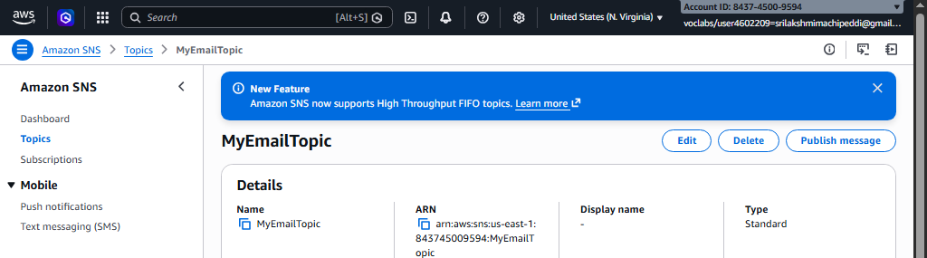
- Add:
  - Subject → Test Mail
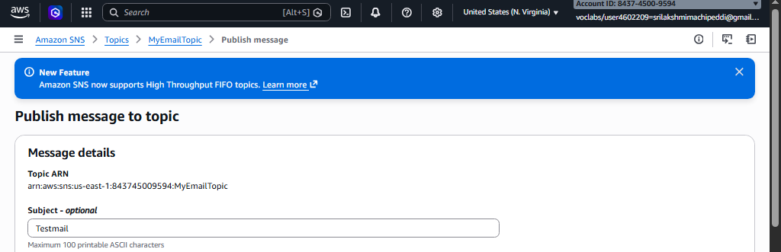
  - Message body → Hello this is SNS test
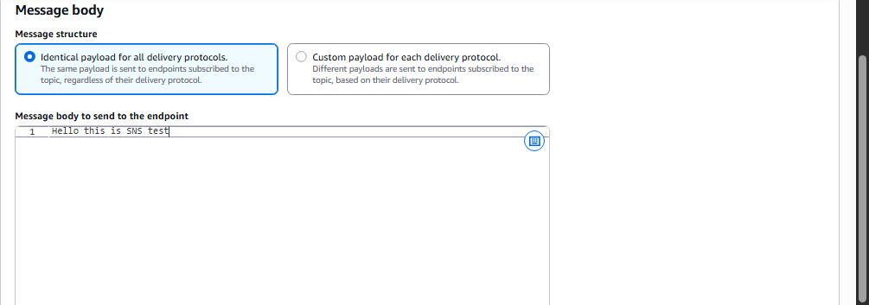
- Click Publish message
You will receive email notification.

B) Trigger Email When S3 Object is Uploaded (S3 → SNS → Email)
Now we extend this setup:
Flow:
S3 Bucket → Event Notification → SNS Topic → Email

Step 1: Create S3 Bucket
- Search → S3
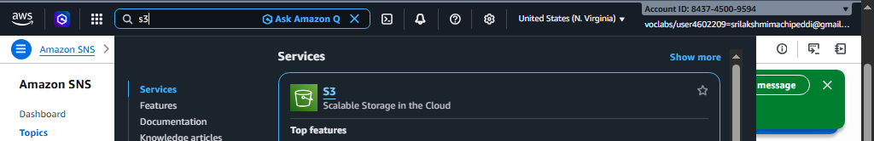
- Click Create bucket

Configure:
- Bucket name → my-upload-bucket-2026
- Choose Region (Important: Same region as SNS topic)
- Keep default settings (unless specific requirement)
- Click Create bucket

Step 2: Create SNS Topic (If not already created)
You can reuse the topic from Part A
OR create new topic like:
- Topic name → S3UploadNotification
Make sure email subscription is confirmed.

Step 3: Allow S3 to Publish to SNS (Access Policy)
- Open SNS Topic
- Go to Access policy
- Click Edit
Add permission for S3 to publish.
If using Basic Editor:
Access Policy that needs to be configured on SNS:
a) replace SNS topic ARN
b) Replace s3 bucket ARN
c) Replace account
{
"Version": "2012-10-17",
"Id": "example-ID",
"Statement": [
{
"Sid": "Example SNS topic policy",
"Effect": "Allow",
"Principal": {
"Service": "s3.amazonaws.com"
},
"Action": [
"SNS:Publish"
],
"Resource": "SNS topic ARN",
"Condition": {
"ArnLike": {
"aws:SourceArn": "s3 bucket ARN"
},
"StringEquals": {
"aws:SourceAccount": "account id"
}
}
}
]
}

(Modern AWS console often auto-generates this when configuring from S3)

Step 4: Configure S3 Event Notification
- Open your S3 bucket
- Go to Properties
- Scroll to Event notifications
- Click Create event notification
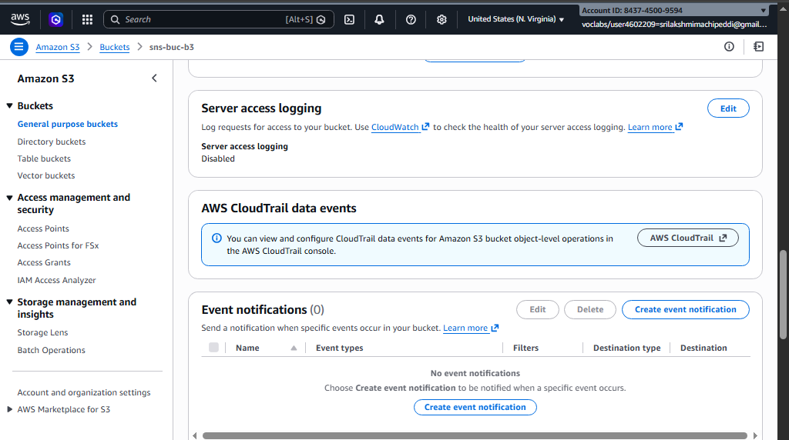

Configure:
- Event name → UploadNotification
- Event types → Select:
  - All object create events
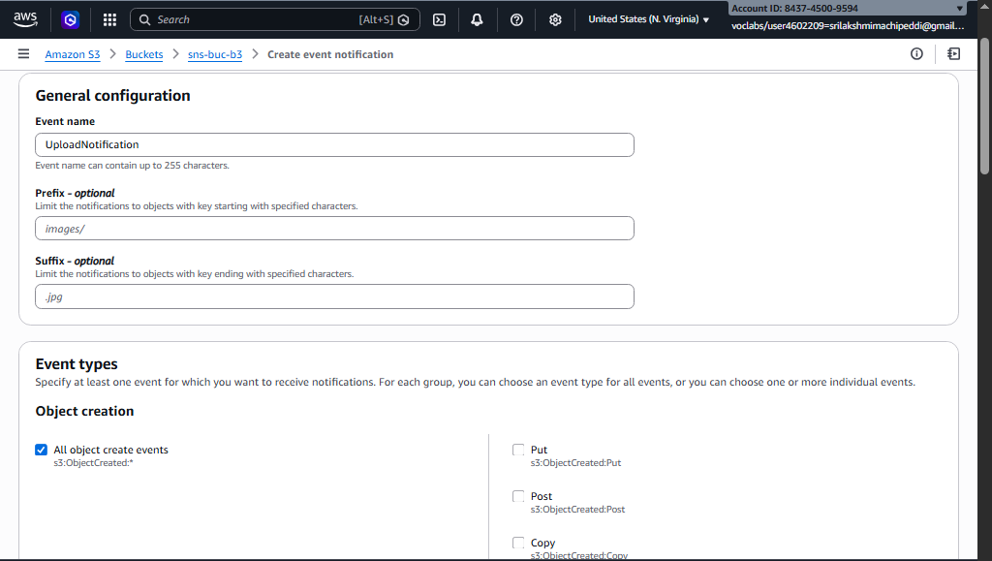
- Destination:
  - Select SNS topic
  - Choose your topic (S3UploadNotification)
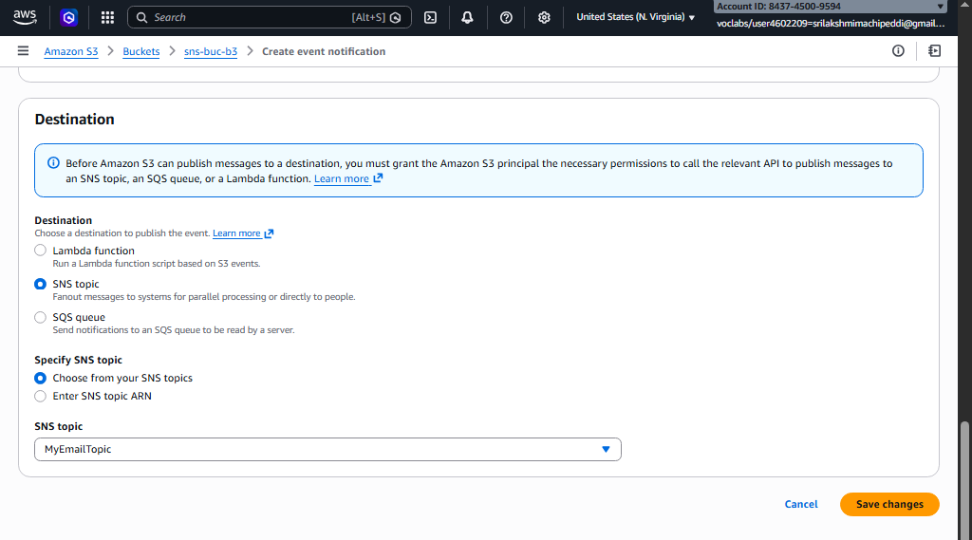
- Click Save changes

Step 5: Test It
- Upload any file into the S3 bucket
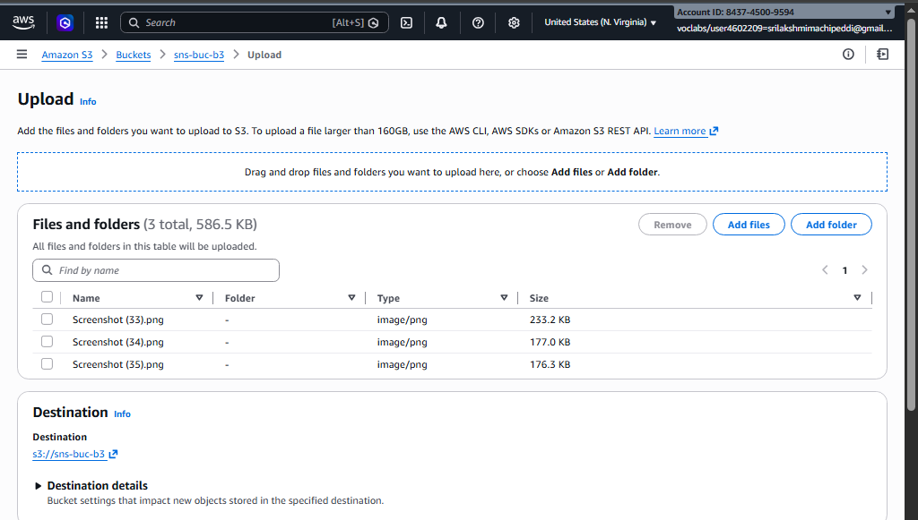
- After upload completes:
  - S3 triggers event
  - SNS receives publish request
  - SNS sends email
You will receive mail about object upload.
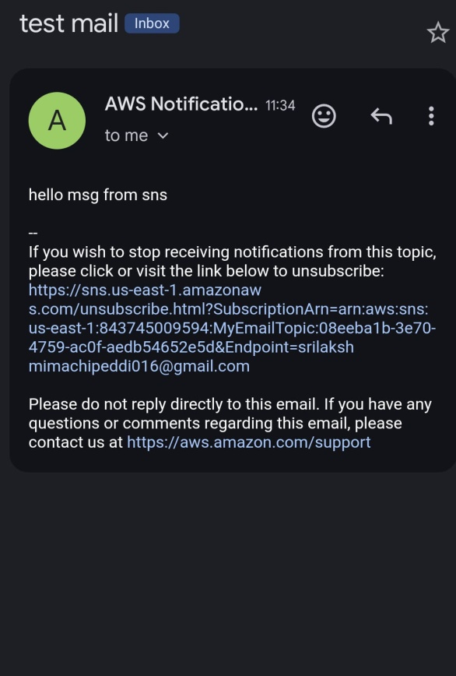

Simple Queue Service (SQS)

2) Create SQS Queue and Send Message
We will:
- Create an SQS Queue
- Send a message to the Queue
- Receive the message from the Queue

Step 1: Create SQS Queue
- Login to AWS Console
- In the search bar → Type SQS
- Open Amazon Simple Queue Service
- In the dashboard → Click Create queue
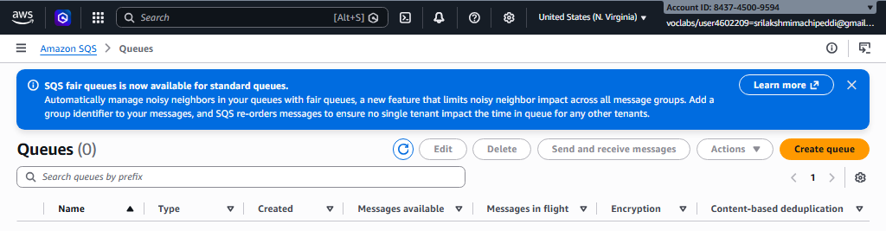
Configure:
• Type → Select Standard
• Name → MyQueue
• Leave other settings as default
- Click Create queue
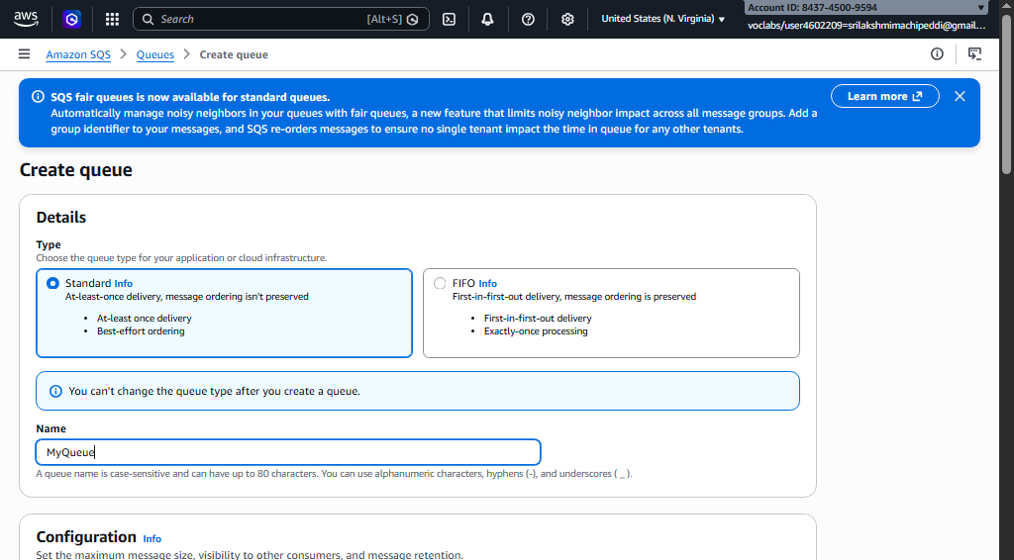
Your SQS queue is now created successfully.

Step 2: Send Message to Queue
- Open the MyQueue queue
- Click Send and receive messages
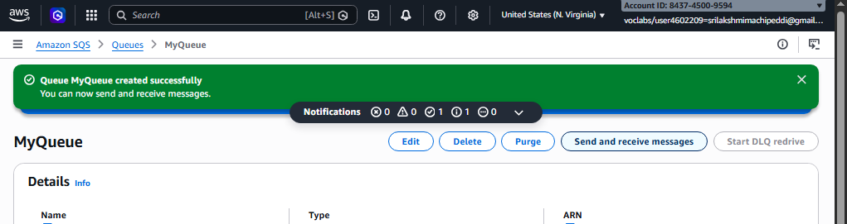
- In the Message body, type:
Hello this is SQS test message
- Click Send message
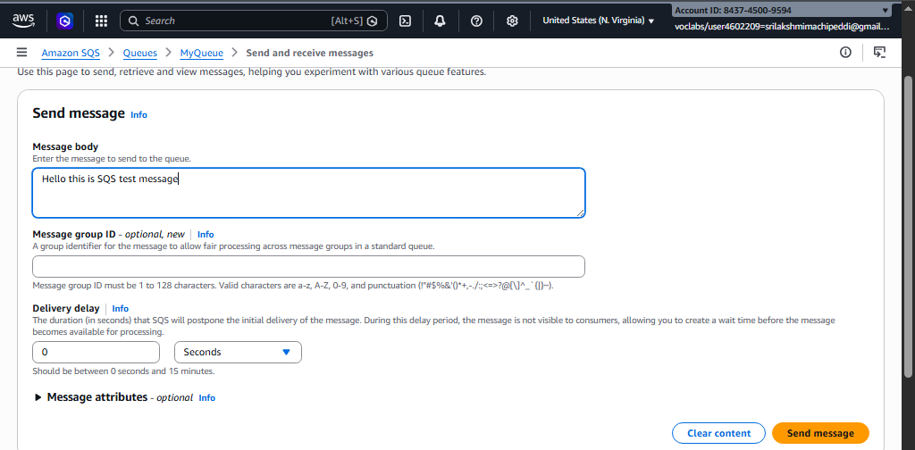
Your message is now stored in the queue.

Step 3: Receive Message from Queue
- In the same page (Send and receive messages)
- Click Poll for messages
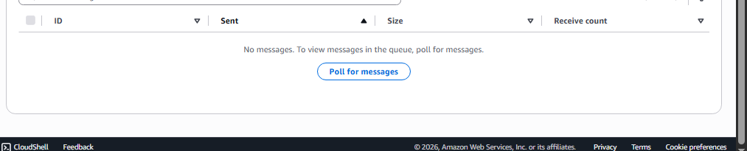
You will see the message displayed.
Example output:
Hello this is SQS test message
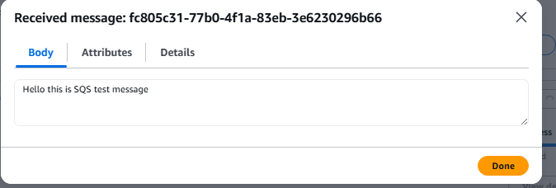
- After processing, click Delete message (optional)
- 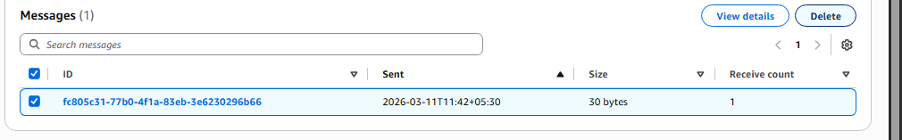

Result:
- SQS queue created
- Message sent successfully
- Message received from queue

3) S3 Bucket Event → SNS → SQS → Lambda Processing
S3 bucket event (like file upload) triggers SNS, which sends the notification to SQS. Then Lambda acts as the consumer and processes the message.
Services used:
• Amazon S3
• Amazon Simple Notification Service
• Amazon Simple Queue Service
• AWS Lambda

S3 → SNS → SQS → Lambda Architecture
S3 Bucket (File Upload)
↓
SNS Topic
↓
SQS Queue
↓
Lambda Function (Consumer)
When a file is uploaded, S3 sends an event notification to SNS, which forwards the message to SQS. The Lambda function then reads and processes the message from SQS.

Step 1: Create S3 Bucket
- Login to AWS Console
- Search S3
- Open Amazon S3
- Click Create bucket
Configure:
• Bucket name → mys3eventbucket123 (must be unique)
• Region → choose your region
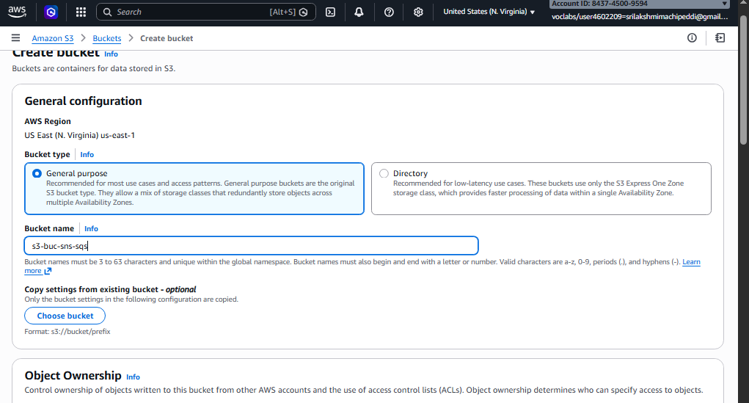
Leave other settings default.
- Click Create bucket

Step 2: Create SNS Topic
- Search SNS in AWS Console
- Open Amazon SNS
- Click Topics → Create topic
Configure:
• Type → Standard
• Name → MyS3SNSTopic
- Click Create topic
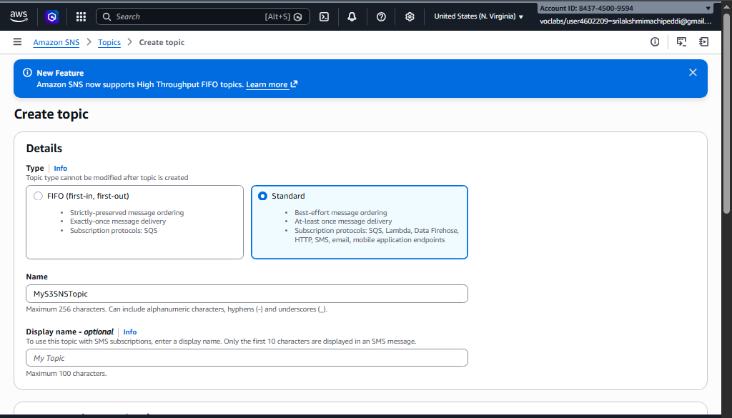
Copy the SNS Topic ARN.
arn:aws:sns:us-east-1:843745009594:MyS3SNSTopic

Step 3: Create SQS Queue
- Search SQS in AWS Console
- Open Amazon SQS
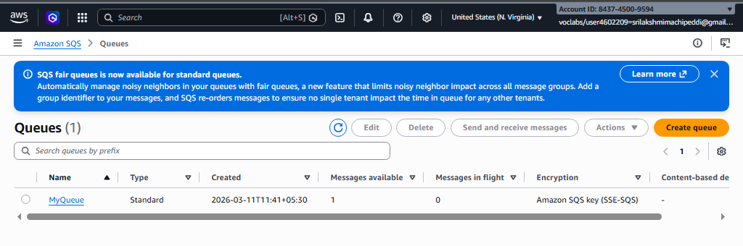
- Click Create queue
Configure:
• Type → Standard
• Name → MyS3Queue
- Click Create queue
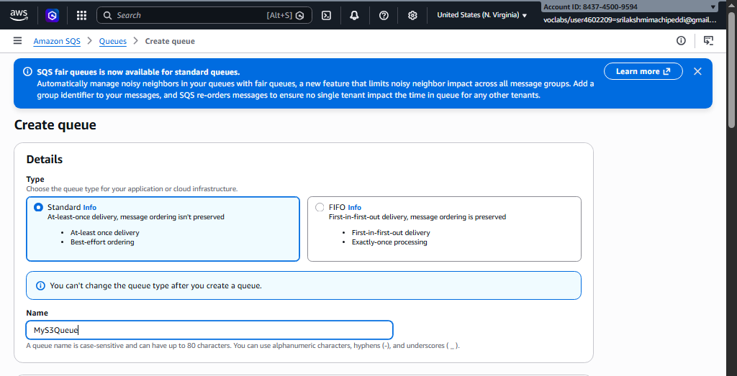
Copy the Queue ARN.
arn:aws:sqs:us-east-1:843745009594:MyS3Queue

Step 4: Subscribe SQS to SNS
- Open MyS3SNSTopic
- Click Create subscription
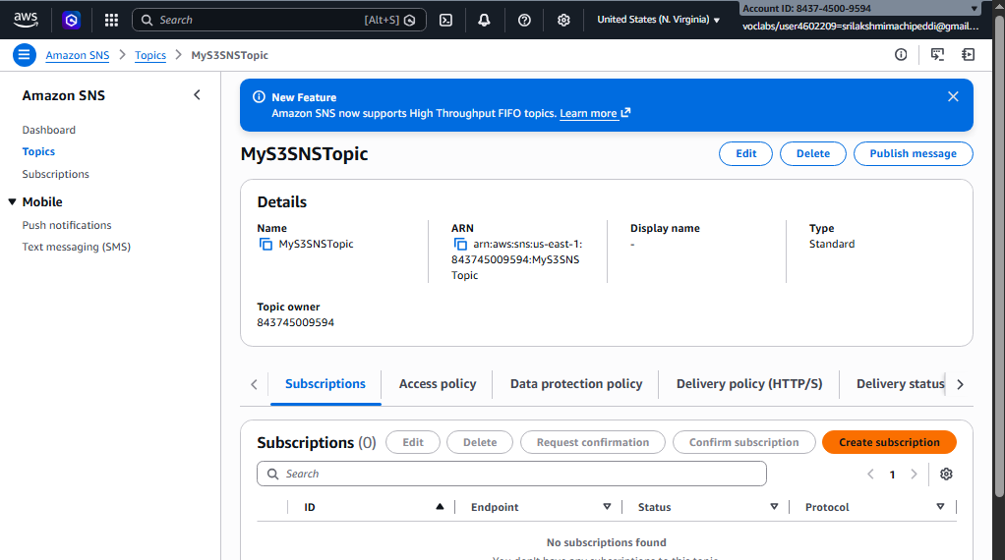
Configure:
• Protocol → Amazon SQS
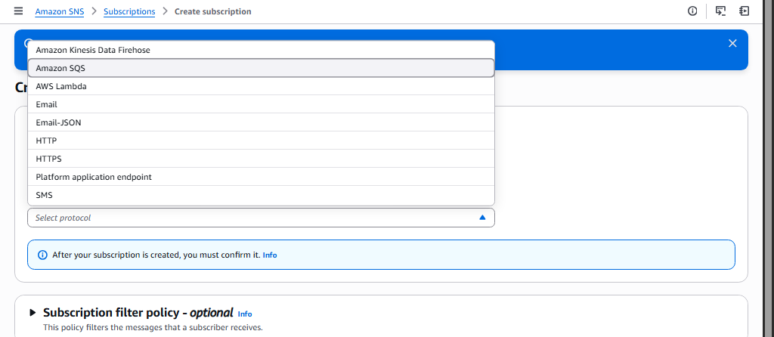
• Endpoint → Select MyS3Queue
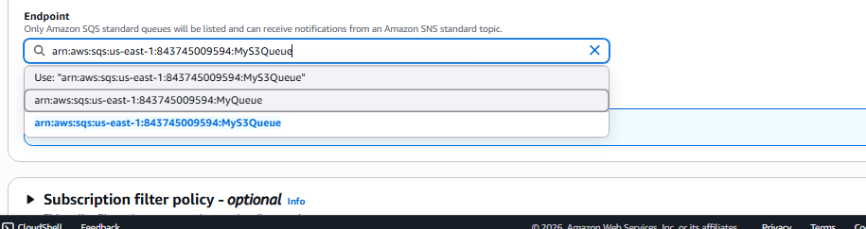
- Click Create subscription

Step 5: Add Access Policy to SQS
Open MyS3Queue → Access Policy → Edit
Replace:
• SQS ARN
• SNS ARN
{
"Statement": [
{
"Effect": "Allow",
"Principal": {
"Service": "sns.amazonaws.com"
},
"Action": "sqs:SendMessage",
"Resource": " arn:aws:sqs:us-east-1:843745009594:MyS3Queue",
"Condition": {
"ArnEquals": {
"aws:SourceArn": " arn:aws:sns:us-east-1:843745009594:MyS3SNSTopic
"
}
}
}
]
}
Click Save.

Step 6: Add Access Policy to SNS
Open SNS Topic → Edit access policy
Replace:
• SNS topic ARN
• S3 bucket ARN
• Account ID
{
"Version": "2012-10-17",
"Id": "example-ID",
"Statement": [
{
"Sid": "Example SNS topic policy",
"Effect": "Allow",
"Principal": {
"Service": "s3.amazonaws.com"
},
"Action": [
"SNS:Publish"
],
"Resource": "SNS topic ARN",
"Condition": {
"ArnLike": {
"aws:SourceArn": "S3 bucket ARN"
},
"StringEquals": {
"aws:SourceAccount": "Account ID"
}
}
}
]
}
Save the policy.

Step 7: Configure S3 Event Notification
- Open S3 Bucket (mys3eventbucket123)
- Go to Properties
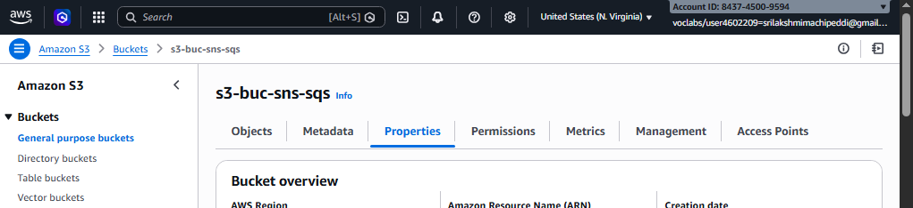
- Scroll to Event notifications
Click Create event notification
Configure:
• Event name → S3UploadEvent
• Event type → All object create events
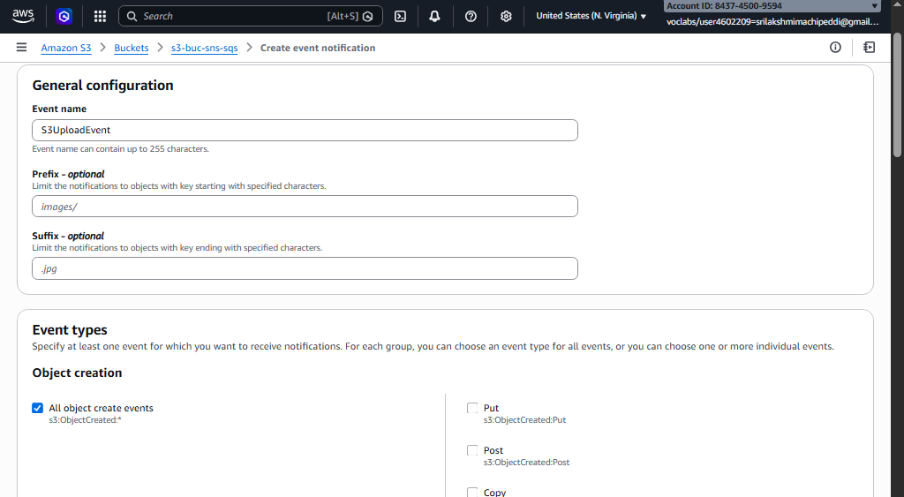
Destination:
• SNS Topic → MyS3SNSTopic
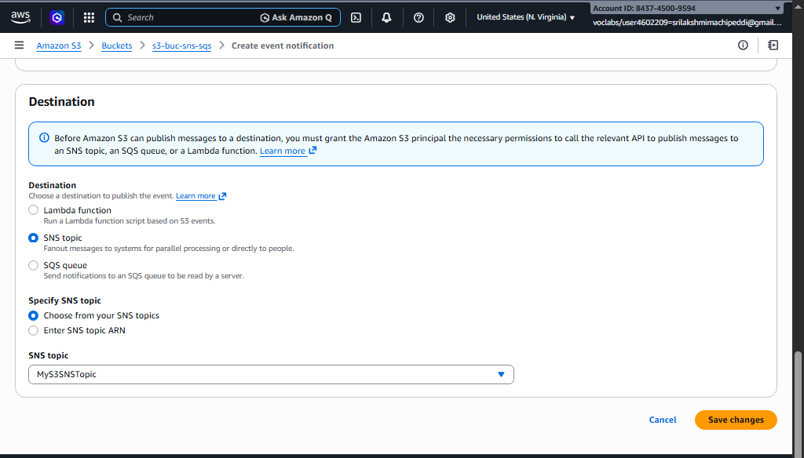
Click Save changes.

Step 8: Test the Architecture
- Open the S3 bucket
- Click Upload file
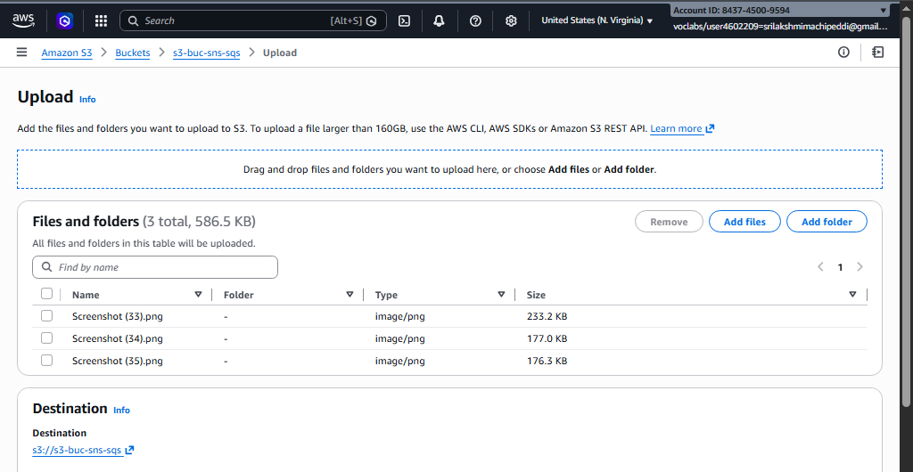
- Upload any file (example: test.txt)
Now:
File Upload → S3
↓
Notification → SNS
↓
Message → SQS

Step 9: Verify Message in SQS
- Open MyS3Queue
- Click Send and receive messages
- Click Poll for messages
You will see the S3 event notification message.
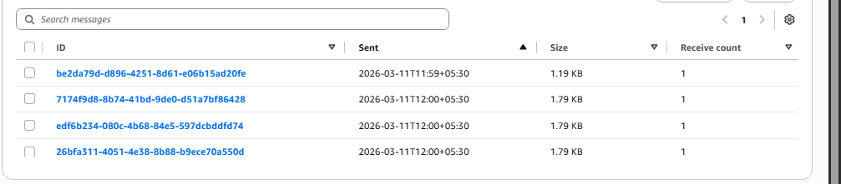

Step 10: Configure Lambda as Consumer
Now configure Lambda to automatically process messages from SQS.
Create Lambda Function
- Search Lambda in AWS Console
- Open AWS Lambda
- Click Create Function
Configure:
• Author from scratch
• Function name → SQSConsumerFunction
• Runtime → Python 3.x
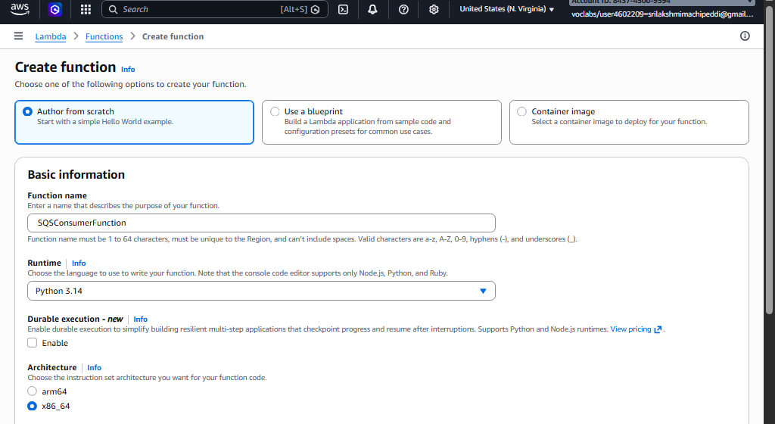
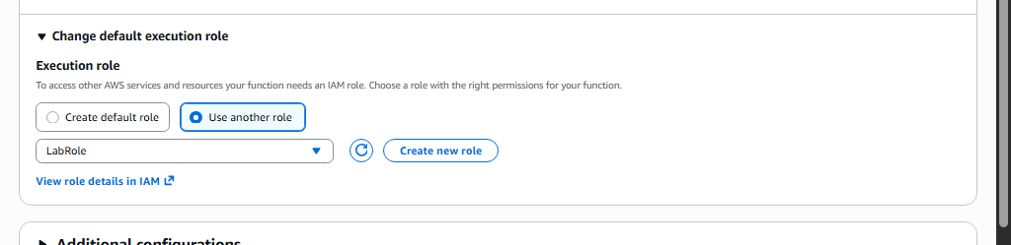
Click Create function

Add SQS Trigger
- Open SQSConsumerFunction
- Click Add Trigger
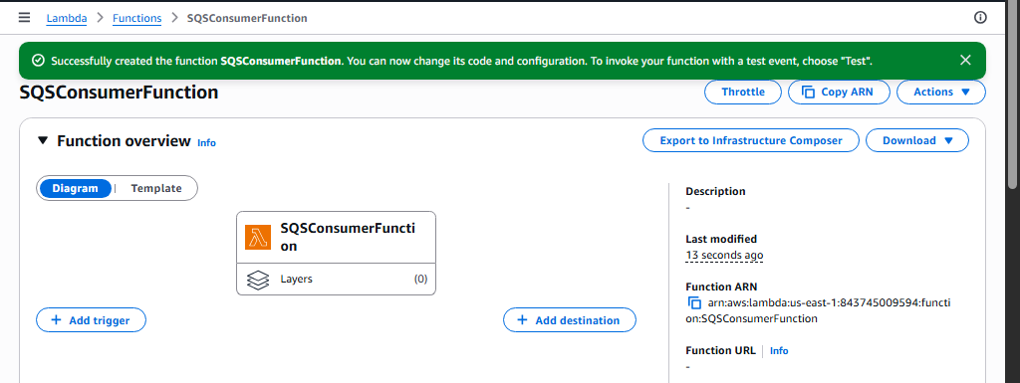
- Select SQS
- Choose MyS3Queue
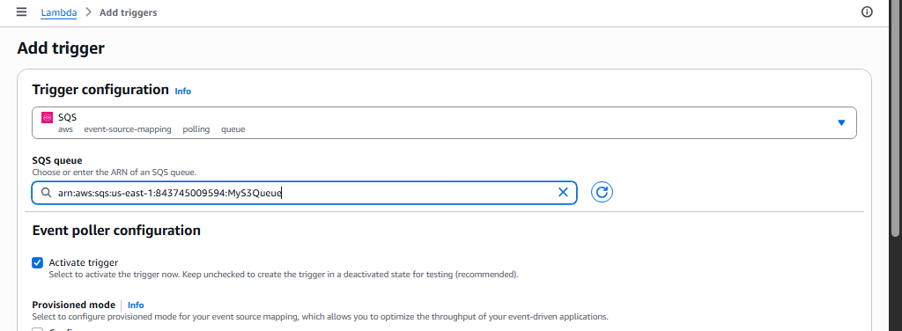
Click Add
Now Lambda will automatically read messages from SQS.

Lambda Code
Replace code with:
def lambda_handler(event, context):

for record in event['Records']:
print("Message received from SQS:")
print(record['body'])

return {
'statusCode': 200,
'body': 'Message processed successfully'
}
Click Deploy.
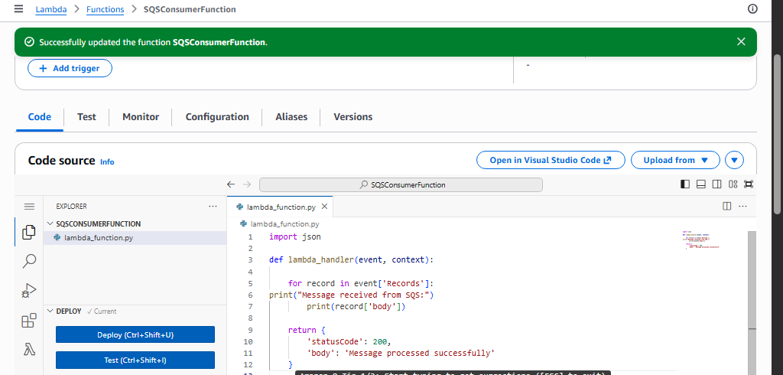

Final Architecture
User uploads file
↓
Amazon S3
↓
SNS Topic
↓
SQS Queue
↓
Lambda Function (Consumer)
↓
Processing / Logs / Database

Result
When a file is uploaded to S3:
- S3 sends a notification to SNS
- SNS forwards the message to SQS
- SQS stores the message
- Lambda automatically reads and processes the message
This creates a serverless event-driven architecture commonly used in real cloud applications.
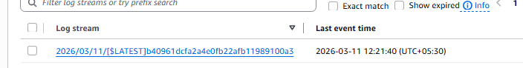
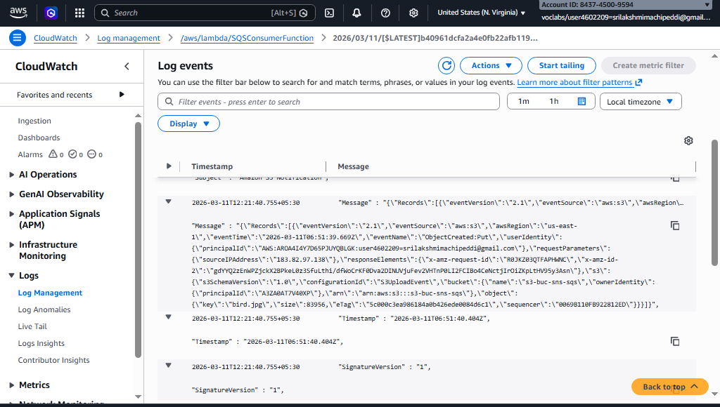

SBQ’s

1. A company wants to automatically process images whenever they are uploaded to an S3 bucket. The system should resize the images and store them in another bucket. Which AWS service can be used to automatically run the code when the image is uploaded?
Answer: AWS Lambda. Configure an S3 event trigger for the source bucket. When a new object is uploaded, Lambda is invoked automatically to resize the image and store it in another bucket.

2. A developer created a Lambda function to store uploaded file details into a DynamoDB table, but the function fails with a permission denied error when writing to the database. What could be the reason and how can it be fixed?
Answer: The Lambda function’s execution role does not have permission to write to the DynamoDB table. Fix: Attach an IAM policy to the Lambda execution role that allows dynamodb:PutItem (or relevant actions) on the target table.

3. An application needs to run a piece of code every time a new file is uploaded to an S3 bucket to extract metadata and store it in a database. How would you design this using AWS Lambda?
Answer: Create a Lambda function that extracts metadata and writes to a database. Configure an S3 event notification on the bucket (for PUT events). Lambda is triggered automatically on each upload.

4. A Lambda function is configured with an S3 trigger, but it is not executing when files are uploaded. What possible configuration issues might cause this problem?
Answer: Possible issues include:

S3 event notification not configured correctly for the bucket.

Lambda permissions missing – the function’s role must allow s3:GetObject.

Wrong bucket or prefix/suffix filters causing no events to match.

Lambda function disabled or deleted.

5. A company wants to process only .jpg image files uploaded to an S3 bucket using Lambda. How can the trigger be configured so that the function runs only for those files?
Answer: Use S3 event notification filtering and set a suffix filter to .jpg when configuring the Lambda trigger. Only objects ending with .jpg will invoke Lambda.

6. A Lambda function works correctly for a few uploads but fails when hundreds of files are uploaded simultaneously. What AWS feature helps Lambda handle large numbers of events?
Answer: Event source scaling. For S3, Lambda automatically scales to handle concurrent events. Consider using Lambda reserved concurrency to manage bursts efficiently.

7. A developer wants to store the table name and bucket name separately from the code so that they can easily change them later. Which Lambda feature can be used to achieve this?
Answer: Lambda environment variables. Store the table name and bucket name in environment variables to make them configurable without changing the code.

8. A Lambda function executes but does not show any output in the console, making debugging difficult. Which AWS service can be used to view logs and troubleshoot the issue?
Answer: Amazon CloudWatch Logs. Lambda automatically writes logs to CloudWatch, where you can view execution logs and troubleshoot errors.

9. An organization wants a function to run every day at 10 PM to clean temporary files stored in S3. How can Lambda be triggered automatically at a scheduled time?
Answer: Use Amazon EventBridge (formerly CloudWatch Events). Create a scheduled rule with cron expression 0 22 * * ? * to invoke the Lambda daily at 10 PM.

10. A Lambda function processes uploaded files and stores metadata in DynamoDB, but duplicate records appear in the table when the same file is uploaded again. How can this issue be prevented?
Answer: Use conditional writes in DynamoDB (ConditionExpression) based on the file’s unique key or hash. This prevents duplicate entries for the same file.

11. A Lambda function processes files uploaded to S3, but the processing sometimes takes more than 10 minutes. What limitation of Lambda must be considered here?
Answer: Maximum Lambda execution time is 15 minutes. For longer processing, consider AWS Step Functions or AWS Batch.

12. A developer wants to allow a Lambda function to read files from S3 and write records into DynamoDB. What type of AWS security configuration must be created?
Answer: Create an IAM role with policies that allow s3:GetObject (or ListBucket) and dynamodb:PutItem (or full CRUD) on the relevant resources. Assign this role as Lambda’s execution role.

13. A company wants to automatically send a notification email whenever a file is uploaded to S3 using Lambda. Which AWS services can be integrated to achieve this?
Answer: Lambda + Amazon SNS. Lambda is triggered by S3 upload, publishes a message to an SNS topic, and SNS sends email notifications to subscribers.

14. A Lambda function is triggered by S3 uploads, but the function keeps running multiple times for the same file. What could be the possible cause?
Answer: Possible causes:

S3 event retried due to Lambda timeout or failure.

Multiple S3 events triggered for the same file (e.g., multipart uploads).

Lack of idempotency in the Lambda code.

15. An organization wants to build a fully serverless application where uploaded files are processed automatically without managing servers. Which AWS services can be combined with Lambda to achieve this architecture?
Answer: Combine the following services:

Amazon S3 – for file storage.

AWS Lambda – for automatic file processing.

Amazon DynamoDB – for metadata storage.

Optional: SNS/SQS – for notifications or decoupling.

Optional: Amazon EventBridge – for scheduled tasks or event routing

